Business Question and Visualization Report
Date | 19 September 2026
Team ID | MCA
Project Name | Online Learning Engagement and Student Performance Analysis
Maximum Marks | 5 Marks

Visualization development refers to the process of creating graphical representations of data to facilitate understanding, analysis, and decision-making. The goal is to transform complex datasets into visual formats that are easy to interpret, enabling users to gain insights and make informed decisions. Visualization development involves selecting appropriate visual elements, designing layouts, and using interactive features to enhance the user experience. This process is commonly associated with data visualization tools and platforms, and it plays a crucial role in business intelligence, analytics, and reporting.

Business Questions and Visualization
The process involves defining specific business questions to guide the creation of meaningful and actionable visualizations in Power BI. Well-framed questions help in identifying key metrics, selecting relevant data, and building visualization that provide insights. The questions below are derived from the Global Online Learning – Student Performance & Engagement Overview and the Risk, Dropout & Demographic Analysis Dashboards.
Business Question | Visualization Type | Screenshot
Which regions have the highest average student scores? | Horizontal bar chart showing Average Score by region | 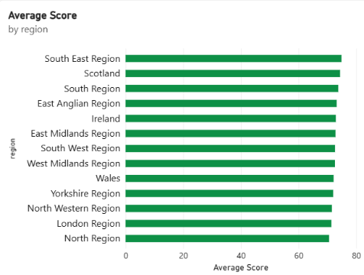
What is the distribution of total students by engagement level? | Pie chart showing Total Students by engagement level (High, Medium, Low) | 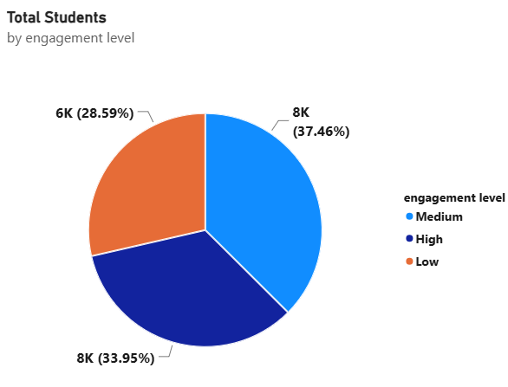
How are students distributed across final results (Pass, Fail, Withdrawn, Distinction)? | Column chart showing Sum of students by final result | 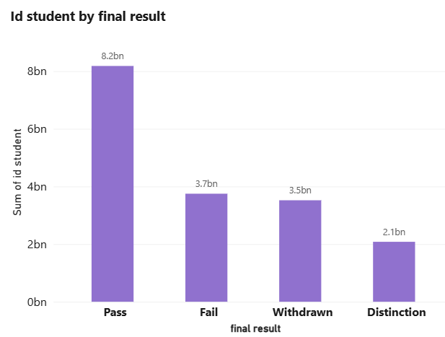
How does average number of clicks vary across engagement levels? | Column chart showing Average Clicks by engagement level | 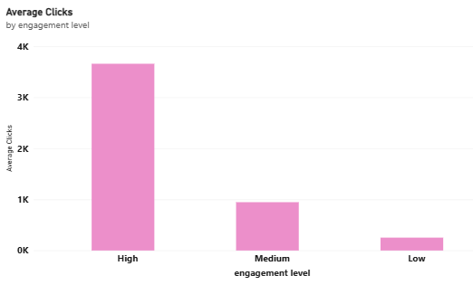
What is the relationship between engagement level and final student results? | Matrix / hierarchical bar chart of engagement level vs. final result | 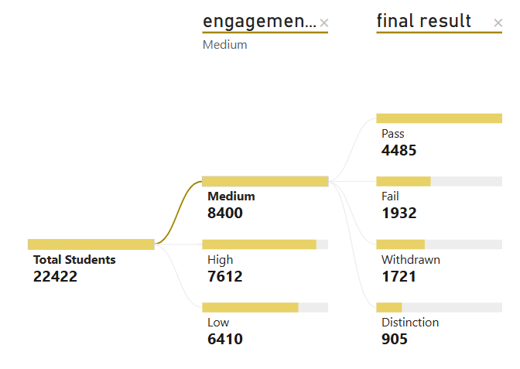
How does dropout rate vary by highest education level? | Column chart showing Dropout Rate by highest education | 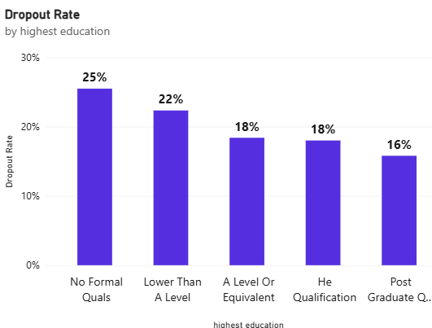
What is the distribution of students by risk level? | Pie chart showing students by risk level (Low Risk, Safe, High Risk, Very High Risk) | 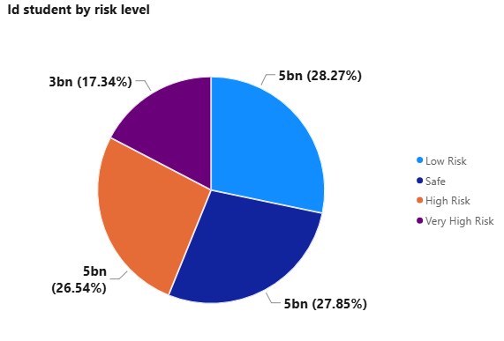
How does pass rate and final result count differ by gender and education level? | Bar charts showing Pass Rate by highest education and Count of final result by gender | 